**ANSWERS 3.8**

1. **.**

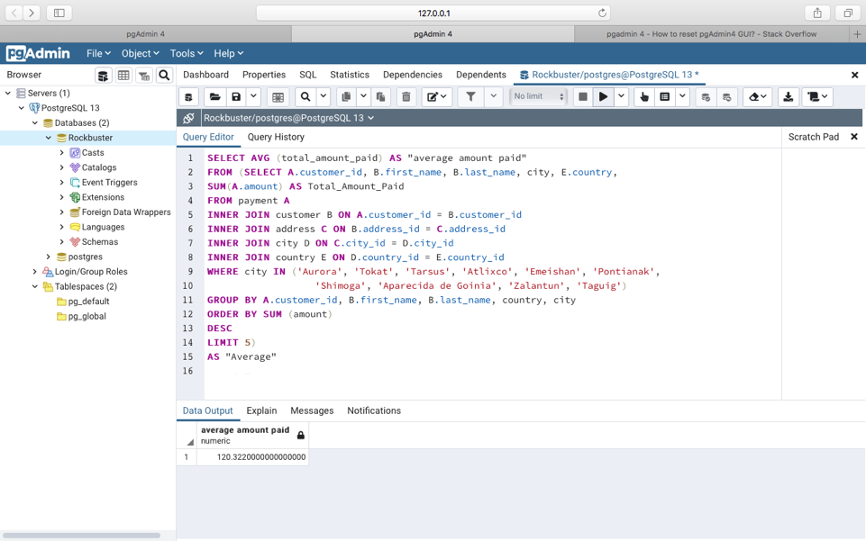

1. **.**

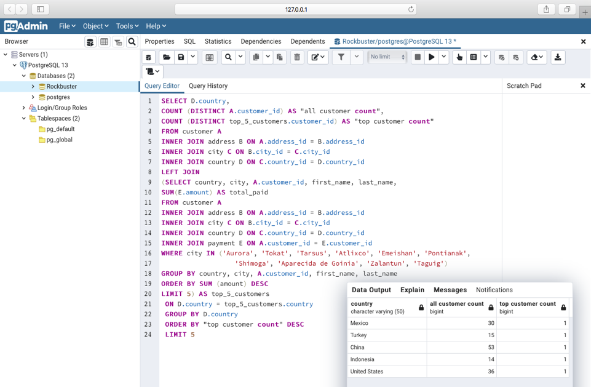

1. **Write 1 to 2 short paragraphs on the following:**

* **Do you think steps 1 and 2 could be done without using subqueries?**

As far as the first step is concern, I can’t think of a different way to find the question to the answer without the subquery. First, we needed to find out the top five spenders from the list of cities and then calculate the average spending of those five people. The best way to do that was by using the subquery.

On the second step however, I believe I could have found the top 5 spending customers without a subquery but using one made things less complicated.

* **When do you think subqueries are useful?**

Subqueries are always useful when trying to create complex queries since we can make smaller and logical queries to retrieve different parts of information and then put them all together. I also think like in this exercise, we can plot queries from the past (subqueries) into new ones to retrieve information and this way we can save some valuable time,